Transformative Potential of Artificial Intelligence and Machine Learning in the Energy Sector: Smart Grids

Dr.A.Manju

*SRM Institute of Science and Technology, Ramapuram, Chennai, India*

[*manjuappukuttan1985@gmail.com*](mailto:manjuappukuttan1985@gmail.com)

Shreyan Krishnaa

*SRM Institute of Science and Technology, Ramapuram, Chennai, India*

[*shreyankrish@gmail.com*](mailto:shreyankrish@gmail.com)

Varun Mandepudi

*SRM Institute of Science and Technology, Ramapuram, Chennai, India*

[*varun8123.vm@gmail.com*](mailto:varun8123.vm@gmail.com)

Nirmal K

*SRM Institute of Science and Technology, Ramapuram, Chennai, India*

[*nirmalkamal03@gmail.com*](mailto:nirmalkamal03@gmail.com)

***Abstract*—** **This comprehensive review explores the transformative potential of artificial intelligence and machine learning, with a particular focus on smart grids. The Global Energy industry faces challenges such as increased consumption, inefficiencies, and erratic demand-supply patterns, the integration of AI and ML technologies offers promising solutions for enhancing energy management, efficiency, and sustainability. This study employs a systematic literature review to assess the integration of AI and ML in the Energy Industry. This integration underlines the significant capabilities of AI and ML in predictive maintenance, energy consumption optimization, power grid management, energy price forecasting, and residential energy demand assessment. Furthermore, this review also delves into the utilization of IoT in advancing the smart grid functionalities, by extracting real-time data among the Electric System Networks. The integration of these technologies enhances the reliability, availability, resilience, stability, security, and sustainability of smart grids. Implementing an ensemble model incorporating Random Forest, XGBoost, and LSTM models for energy forecasting in smart homes was effective. An ensemble method proved more beneficial than single models by decreasing prediction error and providing more stable and accurate forecasts.**

***Keywords—*Artificial Intelligence; Machine Learning; Smart Grids; IoT**

# Introduction

The global energy industry is at a critical juncture, facing uncommon challenges due to increased consumption, inefficiencies in data being collected about the consumption, and erratic demand-supply patterns. Such a critical juncture requires the transition of the Energy industry towards a more sustainable and energy-efficient system. The concept of Smart Grids has emerged as a functional innovation to these challenges. As mentioned earlier, this comprehensive review explores the transformative potential of Artificial Intelligence and Machine Learning with a particular spotlight on Smart Grids, it is essential to understand what smart grids are and how exactly they work.

Smart grids are the advancements of traditional electrical grids that integrate modern technologies such as Artificial Intelligence and Machine Learning to improve the efficiency, reliability, and sustainability of large-scale electricity distributions. Unlike traditional power grids, which primarily deliver electricity in a one-way flow from power plants to consumers, smart grids enable a two-way flow of both electricity and information. This bidirectional flow allows for more dynamic and responsive electrical grid management, incorporating various distributed energy resources, such as renewable energy sources, and enhancing overall grid stability. By combining these techniques, the system aims to offer a more comprehensive recommendation experience. This synergy between content and user-based recommendations aims to provide a richer movie-watching experience.

# Related Work

In the last few years, a lot has been done related to addressing the issue of enhancing the performance and efficiency of smart grid systems by using artificial intelligence (AI), machine learning (ML), and Internet of Things (IoT) technologies. Many authors have addressed both the application of AI and ML, including energy management purposes, demand prediction, as well as enhancement of power system reliability. One of the most interesting areas is that it speaks about the application of ML algorithms in the large-scale data analysis harvested from smart meters, sensors, and so on, in terms of other IoT devices. For example, Alejandro J. del Real, Fernando Dorado, and Jaime Durán (2020) were very eager to indicate how deep learning could be applied in energy demand forecasting. In it, the right prediction was made correctly using historical consumption and weather data. [1] From their research, it has been postulated that AI is going to play a huge role in providing demand forecasting: something that will save much energy while preventing blackouts on the grid. In fact, Zhou et al. (2019) actually concentrated more on real-time load operations wherein the exploitation of reinforcement learning algorithms was considered to be used in optimal real-time energy distribution to develop efficient load-shifting while minimizing the associated costs. However, all of these rely usually on large sets of clean and high-quality data that are hardly accessible or very expensive to obtain; particularly in the underdeveloped regions with the grid infrastructure.[2]

Although energy forecasting and distribution incorporate advanced levels of AI and ML, the existing models still have gaps in scalability and flexibility. Other current studies, for instance, Lin and Zhuang 2021, have focused on localized or regional one-off case studies, therefore making it impossible to extrapolate across the range of grid systems with different true status exteriors.[3] Moreover, the rise of AI in smart grids particularly in the adoption of IoT for smart metering poses a challenge in data security since private data can be transmitted without any restrictions. Karatas et al. (2020) highlighted the vulnerabilities introduced by the IoT-based grid systems and the need for adapting rigorous data transmission methods merged with encryption in the guise to counter attacks in the architectures of the grids.[4] Further on, Zhang et al. (2021) mentioned that the operational and maintenance costs form some of the significant obstacles toward deploying the smart girds solution applied with AI technology. Their findings suggest that while AI may improve system performance and, at the same time, become cost-effective in the short run, the cost of acquiring the requisite technological infrastructures and the eventual operating cost of those systems is a bottleneck amongst poorer economies in the future.[5]

Also, in the last few years, efforts have been made in AI and ML technologies which have a tendency to increase the quality of data - as well as improve the problem of lack of data. For instance, concepts like transfer learning and federated learning have been studied to enhance the outcome of training and deploying models even in areas where scanty locally available data would otherwise degrade their performance. Transfer learning as applied by Chen et al., (2021) lets knowledge and skills acquired in training large-scale generalist-oriented networks be transferred over to that of training fewer yet more focus/domain-oriented networks, making the application of AI become more widespread in sparse data regions. Instead, federated learning will provide an even more potent approach under which the various grid operators can train the model without yielding their raw data in a different setup.[6] This approach presented by Liu et al., (2022) is promising improvement in AI model stability and its applicability to different grid systems and relief of difficulties related to data sharing and collaboration. Putting this aside, though, efforts to embrace such approaches are still at very rudimentary levels of development and any technological or regulatory elements are yet to be developed. [7] In this area, studies on population movements are indeed at the stage whose advancements are at a nascent level, and its attention is at the forefront of developing new strategies to grapple with growing challenges.[8]

A large number of works tend to study theoretical aspects and simulations, with very few going beyond this to field, large-scale implementations. This is the problem of scalability in Susan Ma's bent AI solutions, which remains at the center because, in most cases, grid infrastructure varies from one continent to another, and therefore, they require a high degree of customization, thus limiting the portability of advantages gained. [9] Moreover, most of the literature presently available has evidenced that the potential for energy management optimization and load management using shopping AI has been expended while less attention is received on the prudent management of smart grids and their lifecycle. [10] As Yang et al. have noted, AI predictive maintenance would significantly reduce the downtime and improve the life of performance of the elements of the grid but currently, the AI applications are normally rather short-term and can only raise the operation efficiency. [11]

Further issues in relation to good intelligence in smart projects continue to be regarding data integrity and compatibility. Because IoT devices provide data that is unprecedented, therefore, the reliability of such data is very important and so is its accuracy. Much more extensive is the challenge of integrating AI into traditional systems that were never designed with the requirements of data-driven modern AI models in mind. [12] Most electronic systems especially in developing countries face aged systems, which cannot cope with all data processing and storage required by AI and solutions. Of late, one noticed that good progress has been seen in the application of intelligent machine learning and machine learning in smart grids, but many more challenges are still left to be addressed. These are the remaining lack of available, quality, and secure data and high usage and maintenance costs, which have impeded this technology to a large extent. Finally, it is also the fact that only isolated case studies and regional implementation focus limit the generality of the current study and leave room for further research on global solutions addressed. [13] These contradictions need to be addressed in the research work of the future through the development of models of AI that handle multiple projects and by attempting to evolve new directions such as training in government on issues of Change Education and Training to address the issues of knowledge limitation. Long-term success in the adoption of AI-enabled smart grids will depend on the continued growth of management systems and business models that facilitate the upgrading of safety and efficiency in existing power systems. [14]

These grids, often known as smart grids, represent a sea change from traditional grids that have defined electricity generation for decades. Historically electricity generation had followed a primarily one-way linear model of electricity generated at central power stations and delivered to consumers over power lines and interconnects. Even though the system has satisfactorily served its purpose for so many years, it, however, lacks flexibility and functionality in meeting the varying demands of electricity in today's power and energy systems. The traditional generators put into place for large-scale, fixed power supply now face stiff competition from renewable energy sources such as wind, solar, and hydroelectricity in electricity generation. Smart grids defeat most of the disadvantages through smart technologies, sensors, and automation systems integrated into the grid system. [15]

In this way, they can accommodate more extensive quantities of energy consumption, but with a level of higher reliability, efficiency, and flexibility compared to traditional grids. The difference would be that the point of difference between these two types of grids is that while the original grids do not give instant visibility into the flow of energy, the smart grids can give real-time monitoring and control at different network points from generation to consumption. Instantaneous smart-gird capability to sense changes in energy supply and demand and respond to them, even when regular or unintentional power outages happen. [16]

The general use of smart meters and surge meters characterizes a second important feature of the smart grid. These devices can immediately monitor energy usage in homes and businesses and provide utilities and consumers with timely, accurate information regarding patterns of energy usage. Such information is vital to utilities as it would help them improve distribution across the grid, ensuring proper distribution of electricity and excellent peak demand management. For example, utilities can use this information to encourage customers to shift usage to off-peak hours to flatten the load on the grid during peak demand. In addition to such applications, smart meters and sensors can quickly detect faults or attacks much faster than any other technology, offering faster alert times and better customer reliability. Other very important drivers for smart grid adoption are the development of decentralized energy sources or so-called DERs such as solar panels, wind turbines, electrical vehicles, and storage battery systems. [17]

Smart grids will help in decreasing reliance on fossil fuels through an increase in local production and storage, which helps reduce greenhouse gas emissions and supports more sustainable energy for the future. This permits the grid to hold its stability during times of low sunshine and low winds because all excess energy generated in the daytime by generators such as photovoltaics can be stored. It remains non-competitive, though. So far, one of the biggest challenges that its development faces is how to integrate massive electric power into the grid. The other differentiation for renewable energy production is that it depends on a number of other natural factors such as the sun and, more importantly, wind patterns, which cannot be controlled or predicted easily. This change makes it very difficult for grid operators to balance power and demand. [18]

Large-scale renewables and the integration of global energy mix, however, are still a major challenge, especially for renewables. Another major challenge facing current smart systems is data management. Smart meters and counters generate large amounts of data every second, including what you need to know at a detailed level in terms of energy usage, physical activity, and the environment. After all, most networks in organizations battle with the amounts of data analysis or processing that ought to be made in real time. Consequently, if critical information is lost due to inadequate and inefficient data analysis, poor decision-making and network performance will ensue. For example, if grid operators can't analyze data in real time, the operators will not be prompt to react to changes in the demand for energy or availability of energy. This consequently results in power loss or electric power loss.[19]

Additionally, as smart grids are well integrated via IoT, cybersecurity threats also grow. The more that connectivity and dependency on digital technology increase, the vulnerability of smart grids to cyber-attacks also increases. Such an attack on the grid can temporarily stop it from continuing its delivery function or otherwise enable the theft of customers' information.[20] These threats are more acute today since the IoT interconnectivity is growing and wannabe hackers find new means of access, so the security and resilience of smart projects should be essential to utilities and governments when dealing with cyberattacks against critical systems, which are destructive in case performed voluntarily.

In brief, though the smart grids of the present era are more advanced than the previous ones, they are not confined to these. Some of the issues concerning the modern electric grid that it needs to evolve through include the integration of large-scale renewable energy, management of big data, and network security. Increasing the capacity of the grid to hold in more renewable energy, increase in data processing capacities, and strengthening energy security measures are key to achieving sustainable, good, reliable, and powerful energy.

# AI & ML Integrated Smart grids

The architecture diagram for the proposed AI and IoT-integrated smart grid system contains a hybridization of real-time data acquisition, machine learning, and predictive analytics. Pre-processing cleans and structures data that is being acquired from the smart devices and IoT sensors before applying machine learning models in predicting energy demand, load balancing, and optimizing decision-making for energy distribution. If renewable energy sources are integrated, then the system checks the presence of such resources and accordingly increases the grid load. The AI models predict the conditions persistently and update this by historical data, real-time information, and other external influences such as weather conditions.

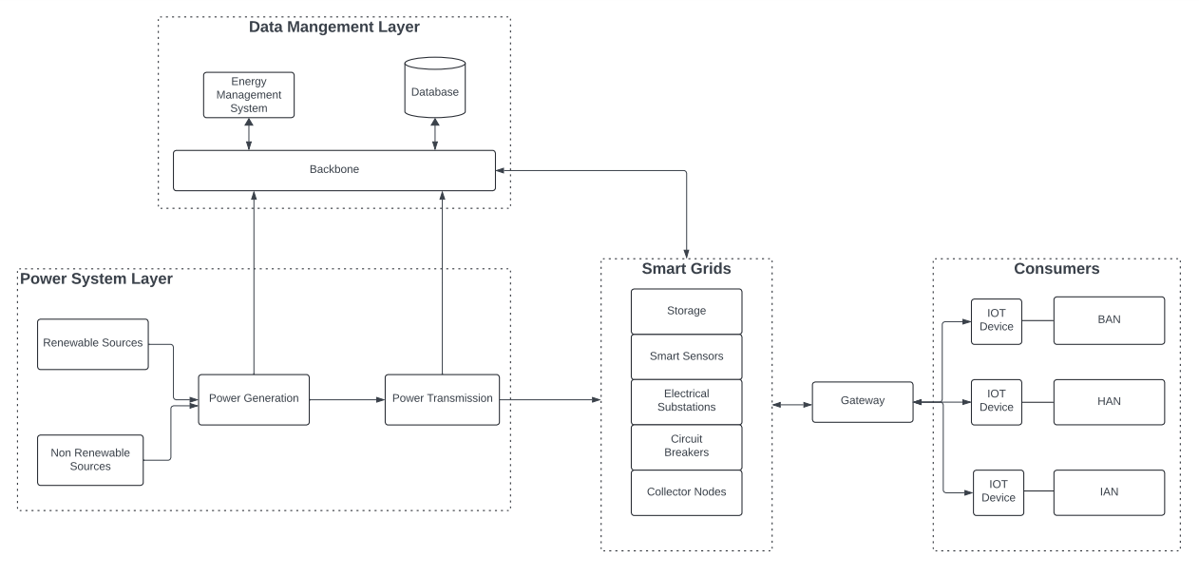

Fig.1 Architecture Diagram of the Smart Grids

**Data Gathering and Pre-processing:** The proposed system gathers data from various IoT devices such as smart meters sensors and renewable energy sources. The dataset contains real-time energy usage, environmental variables like temperature and sunlight, and the performance of the grid. All this is then preprocessed, which involves cleaning up any inconsistencies that could be present in the data, transforming the different formats to another format so they can be compared effectively, and feature extraction to emphasize relevant variables. This keeps the data structured and well-arranged so that machine learning models can process it effectively.

**Data Collection Layer:**

* **Smart Meters:** The smart meters provide essential data on the electrical transfer within the smart grids which can be used for predictive maintenance and fault detection.
* **IoT devices:** The IoT devices are equipped at the terminal nodes or consumers that provide information on electrical demand and usage which can be used for load forecasting, enhanced supply system, and energy optimization.

#### **Data Management Layer:**

#### **Data Cleaning and Transformation:** The input data is pre-processed once a user query or interaction is received. It is the cleaning of the data from noise and transforming it into structured data that can be analyzed.

#### **Data Storage:** The pre-processed data is stored in the databases which can be used for computation and predictive analysis.

#### **Data Analysis:** The preprocessed data is used for data computation, Data analysis, Predictive analysis, Load forecast, Consumption forecast, Predictive maintenance, and Fault detection.

**Data Pre-Processing:**

**Feature Scaling:** Energy consumption values and other input features were normalized using MinMaxScaler to ensure that all values were between 0 and 1. This normalization process is very crucial when it comes to machine learning algorithms, especially in the case of neural networks and tree-based models where the input data scale matters. Considering our design, by scaling the data, we mitigated the concerning prospect of a model being biased towards certain overrepresented features because of their larger scale, meaning all features were treated fairly during model training. This also had the effect of faster and more efficient convergence properties of the models during the optimization process.

**Training and Testing Split:** The dataset was Stratified into training and testing sets. Aids in the building of models were provided by the use of the training data while the models were assessed on new data by the borne data. With this, oversimplification of the models or memorizing and screaming the training data was avoided, and information up to that point not encountered was accepted by the models.

**Predictive Analytics and Load Forecasting:** After the pre-processing is done, it puts the machine learning algorithms to prediction on future energy demands and optimization of energy distribution. For example, it uses regression models and neural networks to predict how much energy will be consumed during the short-run future by taking into consideration historical patterns along with real-time data inputs. It is this kind of prediction that allows the grid to adjust power generation to neither overload it nor fall into shortage. Advantage: Predictive analytics makes it possible to proactively manage the grid, making adjustments based on peak demand periods and energy flow beforehand. The system also uses weather forecasting to anticipate renewable resources like solar or wind energy sources and optimize its integration into the system.

**AI-Based Load Balancing:** AI algorithms use their models to optimize load balancing by dynamically ensuring that electricity is distributed throughout the grid. The system analyzes real-time consumption data and makes sure that supply meets demand in an efficient manner. Algorithms based on reinforcement learning are there in the system, such that the grid can "learn" about its earlier actions and refine its decision-making over time. Whenever a specific part of the grid experiences a spike in demand, AI models predict this and redistribute electricity so that the system does not overload. It also eliminates power cuts and minimizes energy losses.

**IOT Integration for DERs:** The system integrates data from DERs like wind turbines, solar panels, and storage systems. The system can monitor the functioning of decentralized sources of power through IoT sensors and predict their energy contribution to the grid. In cases where the grid generates excess energy from the panels during the day, this is stored for use at night or even during peak times when there is demand. The system is rounded up further through the integration of electric vehicles into the grid, where their batteries could serve both as a means to store energy and as a source when there is excess supply. The smooth incorporation of DERs enhances the resilience within the grids and encourages the use of renewable sources of energy.

**Fault Detection and Predictive Maintenance:** AI algorithms continuously monitor the grid for faults or inefficiencies. Machine learning models are trained against historical data to detect anomalies in the performance of the grid. That way, the system may raise its concerns before it becomes a more serious failure. The system applies predictive maintenance techniques in assessing grid components. Analysis of the data given by IoT sensors attached to transformers, power lines, and other critical infrastructure will enable the system to predict when equipment is likely to fail and schedule maintenance proactively. This implies the avoidance or reduction of downtime, saving the costs of repairs, and extending the life of infrastructure in the grid.

**Decision-Making and Energy Optimization:** AI models consider an optimization algorithm to determine whether excess energy should be stored or used immediately. Once again, this process balances immediate and short-term needs against the stability required by the long term in the grid and finds a win-win situation for consumers and utility companies. For example, the surplus can be accumulated or stocked within the battery system during charging when the energy demand is at its peak so they do not go to waste.

**Outcome of Combined AI and IoT System:** The installation of an AI and IoT-based smart grid system results in the creation of a hybrid model wherein energy usage and distribution are continuously optimized. Through the hybrid approach, whereby real-time data from the IoT devices is incorporated into the machine learning algorithms, the system will be able to adapt to changes in conditions in real-time. The use of this hybrid approach enhances efficiency, resilience, and its capability to accommodate renewable energy sources within the grid. Its self-learning capability also enables it to improve with time as more data are presented. This will ultimately yield a much more dependable and efficient grid that is sustainable and scalable for future energy needs.

**Benefits:** A smart grid based on AI and IoT has the following key benefits:

* Real-Time Data Processing and Machine Learning Are Keys to Enhanced Efficiency: The system optimizes energy distribution with fewer losses and more reliability.
* Resiliency: Distributed energy and predictive maintenance ensure that when the grid senses a change, it acts promptly to avoid the worst-case scenario of a probable outage.
* Sustainability: The system accommodates the consumption of renewable sources of energy, reducing reliance on fossil fuels and nudging the globe towards attaining a sustainable source of energy.
* Predictive Capability: The use of predictive analytics makes it possible for the grid to predict the demands and supplies of energy and, based on that data in input form from both the real-time and historical values, distribute as much energy as efficiently as possible.
* Scalability: it can easily scale up with the increase in the number of integrated IoT devices and renewable energy sources, making this design well-suited for energy requirements in the future.

**Model Development:** Deepening our understanding and achieving a believable vision of energy use in the future, we took the measures of implementing and hand-tuning three machine learning algorithms:

**Random Forest Regressor:** An effective Ensemble learning method, Random Forest does so by creating numerous decision trees and takes the average of all the trees' results. This algorithm is very efficient and effective when there are nonlinear relationships in the data. Random Forest was considered appropriate for its strength, and its ability to work with high dimensional data in a risk-controlled manner against overfitting usually associated with the use of single decision trees.

**XGBoost Regressor:** XGBoost (Extreme Gradient Boosting) is an optimized implementation of the gradient boosting framework, which is an incremental technique of building models, where each new model addresses the residuals of its predecessor. XGBoost's capabilities in understanding the very complex contours of data patterns like it is found in the current task and the huge sizes of data expected in this exercise explain its choice.  
  
**Long Short-Term Memory Network (LSTM):** Considering that the energy expenditure data is time-dependent, we employed LSTM, which is a type of recurrent neural network (RNN) that is constructed to ensure the preservation of long-range dependency in time series data. LSTM networks are particularly efficient in recognizing over time changes in a pattern and therefore tend to be useful in predicting future energy consumption trends from the past data.

**Ensemble Prediction:** To further the accuracy of the predictions, we used an ensemble method that combined predictions from three models of prediction. The ensemble model operated to exploit the strength of each of these individual models so that any weak point a single model could have is not present. This approach was made because ensemble models, often resulting in more stable and accurate predictions, give outputs of multiple models put together.

The Prediction models are:

* Random Forest Regressor
* XGBoost Regressor
* Long Short-Term Memory Network

The ensemble approach resulted in more robust predictions since each model contributed complementary information. The ensemble strategy mitigated the risks of overfitting associated with individual models and improved generalization performance on unseen data.

**Model Evaluation:**

**MAE:** This is the average absolute difference between the actual and the predicted values. It gives an absolute measure of how close in terms of value predictions are to a true value to energy usage

**RMSE:** RMSE is a common metric used in regression tasks, for which one computes the square root of the average squared differences between the real and estimated values. For all practical purposes, it gives higher weights to large errors, which means that it's generally sensitive to outlier values.

Having found the values of MAE and RMSE of the ensemble model, the result indicated:

|  |  |
| --- | --- |
| **Parameter** | **Values** |
| MAE | 1415.19 |
| RMSE | 1671.86 |

Table 1. Values of Parameters

1. RESULT AND DISCUSSION

**Graphical Representation:** A line plot was created to be able to plot graphically the differences that emerged between actual and predicted energy consumption values for the entire test period. The plot provided a clear intuitive basis by which one could judge how closely the predictions tracked actual consumption patterns.

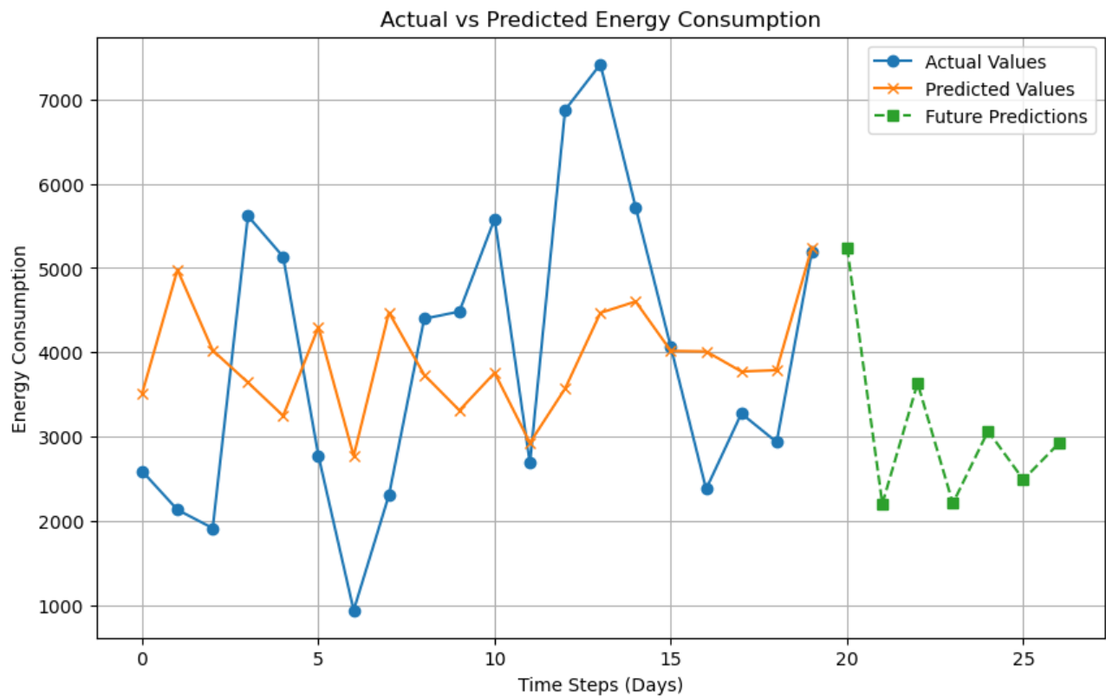

Fig.2 Visualization of the output

**Tabular Representation:** A table is developed for actual and predicted values of consumption of energy and also for its prediction of future consumption. The table also had the predicted values of the calculated test data along with the future values for better judgment regarding the predictive strength of the model over time.

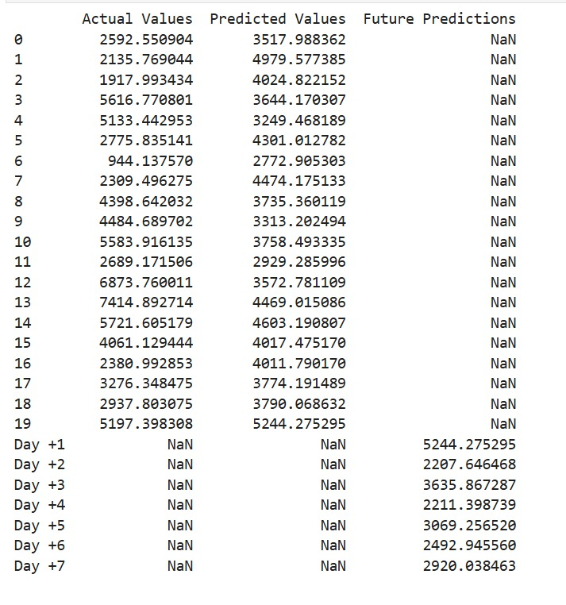

Fig.3 Prediction of Future Energy Consumption

1. CONCLUSION

Artificial Intelligence and Machine Learning, two other significant integrations into the smart grid's infrastructure, enhance its energy system more strongly. Both of these technologies help in processing large data streams that come in real-time thus making predictive analytics simpler, fault handling easier, and resource optimization easier as well whereby good efficiency for smooth grid operations is achieved through better load forecasting and electricity supply strategies, especially in renewable energy sources. Improvements in semiconductor technology naturally contribute towards increased automation and lesser humanizing in decision-making processes.

The approach applied is an ensemble strategy that includes Random Forest, XGBoost, and LSTM models. At the smart homes, practical experience has established their efficiency in terms of stable and accurate predictions compared to the single models. The graphical and tabular aids resulting from this research help to underscore the effective performance of advanced methodologies in forecasting energy consumption and expose the underutilization of ensemble methods. Further work would be on model optimization: hyper-parameter tuning; feature enhancement; and utilization of these models across various datasets.

VI. REFERENCES

[1] Alejandro J. del Real, Fernando Dorado, Jaime Durán ”Energy Demand Forecasting Using Deep Learning: Applications for the French Grid”,

[2] M. Manasa, C. Mahesh, B. S. Harish "Artificial Intelligence Techniques for Smart Grid Applications: A Review", Journal of Energy Storage

[3] M. I. Ahmad, J. Alam, M. A. Hossain, A. Al-Durra "Deep Learning for Smart Grid Applications: Opportunities, Challenges, and Future Directions", IEEE Transactions on Smart Grid

[4] N. Javaid, I. Khan, A. M. Alabed, M. Imran, A. Almogren "Machine Learning Techniques for Smart Grid: A Comprehensive Review", IEEE Access

[5] S. R. A. Abbas, M. A. Abido, I. Husain "AI-Based Techniques for Power System Security and Stability Enhancement in Smart Grid Environment: Current Issues and Future Directions", Energies

[6] S. Khan, S. Rehman, M. Mahmud "Smart Grid and Artificial Intelligence: A Review", International Journal of Energy Research

[7] Mengyuan Liu, Zuyi Li, Xiaoyu Song "A Review of Machine Learning Applications in Smart Grid", Energies

[8] Idries, A.; Krogstie, J.; Rajasekharan, J. Dynamic Capabilities in Electrical Energy Digitalization: A Case from the Norwegian Ecosystem. Energies 2022,15, 8342.

[9] Grosse, M.; Send, H.; Schildhauer, T. Lessons Learned from Establishing the Energy-Informatics Business Model: Case of a German Energy Company. Sustainability 2019, 11, 857.

[10] Akhtar, S.; Sujod, M.Z.B.; Rizvi, S.S.H. An Intelligent Data-Driven Approach for Electrical Energy Load Management Using Machine Learning Algorithms. Energies 2022, 15, 5742.

[11] Zeng, F.; Qi, G.; Zhu, Z.; Sun, J.; Hu, G.; Haner, M. Convex Neural Networks Based Reinforcement Learning for Load Frequency Control under Denial of Service Attacks. Algorithms 2022, 15, 34.

[12] Mosavi, A.; Salimi, M.; Faizollahzadeh Ardabili, S.; Rabczuk, T.; Shamshirband, S.; Varkonyi-Koczy, A.R. State of the Art of Machine Learning Models in Energy Systems, a Systematic Review. Energies 2019, 12, 1301.

[13] Kabbara, N.; Nait Belaid, M.O.; Gibescu, M.; Camargo, L.R.; Cantenot, J.; Coste, T.; Audebert, V.; Morais, H. Towards Software-Defined Protection, Automation, and Control in Power Systems: Concepts, State of the Art, and Future Challenges. Energies 2022,15, 9362.

[14] Zakaret, C.; Peladarinos, N.; Cheimaras, V.; Tserepas, E.; Papageorgas, P.; Aillerie, M.; Piromalis, D.; Agavanakis, K. Blockchain and Secure Element, a Hybrid Approach for Secure Energy Smart Meter Gateways. Sensors 2022, 22,9664.

[15] Binyamin, S.S.; Ben Slama, S. Multi-Agent Systems for Resource Allocation and Scheduling in a Smart Grid. Sensors 2022, 22, 8099.

[16] AL-Jumaili, A.H.A.; Mashhadany, Y.I.A.; Sulaiman, R.; Alyasseri, Z.A.A.A Conceptual and Systematics for Intelligent Power Management System-Based Cloud Computing: Prospects, and Challenges. Appl. Sci. 2021, 11,9820.

[17] Ahuja, Rishabh, Arun Solanki, and Anand Nayyar. "Movie recommender system using k-means clustering and k-nearest neighbor." 2019 9th International Conference on Cloud Computing,Data Science & Engineering (Confluence). IEEE, 2019.

[18] Singh, Ramni Harbir, et al. "Movie recommendation system using cosine similarity and KNN." International Journal of Engineering and Advanced Technology 9.5 (2020): 556-559.

[19] Huang, Yao-Chang, and Shyh-Kang Jenor. “An audio recommendation system based on audio signature description scheme in MPEG-7 Audio.” 2004 IEEE International Conference on Multimedia and Expo (ICME) (IEEE Cat. No.04TH8763), doi:10.1109/icme.2004.1394273.

[20] Habibi, M.R.; Golestan, S.; Soltanmanesh, A.; Guerrero, J.M.; Vasquez, J.C. Power and Energy Applications Based on Quantum Computing: The Possible Potentials of Grover’s Algorithm. Electronics 2022, 11, 2919.

[21] Minh, Q.N.; Nguyen, V.-H.; Quy, V.K.; Ngoc, L.A.; Chehri, A.; Jeon, G. Edge Computing for IoT-Enabled Smart Grid: The Future of Energy. Energies 2022, 15, 6140.

[22] Kim, J.-W.; Kim, J.; Lee, J. An Adaptive Network Design for Advanced Metering Infrastructure in a Smart Grid. Sensors 2022, 22, 8625.

[23]Kabalci, Y. A Survey on Smart Metering and Smart Grid Communication. Renew. Sustain. Energy Rev. 2016, 57, 302–318.

[24] Pereira, H.; Ribeiro, B.; Gomes, L.; Vale, Z. Smart Grid Ecosystem Modeling Using a Novel Framework for Heterogenous Agent Communities. Sustainability 2022, 14, 15983.

[25] Bakkar, M.; Bogarra, S.; Córcoles, F.; Aboelhassan, A.; Wang, S.; Iglesias, J. Artificial Intelligence-Based Protection for Smart Grids. Energies 2022, 15, 4933.

[26] El Maghraoui, A.; Ledmaoui, Y.; Laayati, O.; El Hadraoui, H.; Chebak, A. Smart Energy Management: A Comparative Study of Energy Consumption Forecasting Algorithms for an Experimental Open-Pit Mine. Energies 2022,15, 4569. [CrossRef]

[27] Xu, C.; Liao, Z.; Li, C.; Zhou, X.; Xie, R. Review on Interpretable Machine Learning in Smart Grid. Energies 2022, 15, 4427.

[28] Jaiswal, R.; Davidrajuh, R.; Rong, C. Fog Computing for Realizing Smart Neighborhoods in Smart Grids. Computers 2020, 9, 76.

[29] Shahzad, M.; Qadir, A.; Ullah, N.; Mahmood, Z.; Saad, N.M.; Ali, S.S.A. Optimization of On-Grid Hybrid Renewable Energy System: A Case Study on Azad Jammu and Kashmir. Sustainability 2022, 14, 5757.